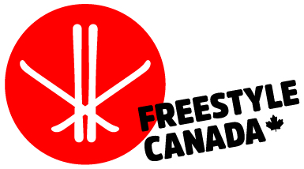
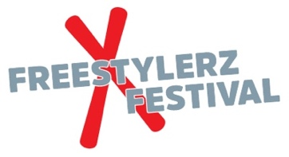

FREESTYLERZ FESTIVAL
SOCIAL MEDIA GUIDE

#freestylecanada
#freestylerzfestival
@freestylecanadaski

Post on: (if available)
  - Facebook Group
  - Instagram Account
  - Website

Pre-Event (app 3 weeks before event)
- Suggested Post
  - Branded Logo FC, Freestylerz Festival logo
  - Action Shot of Athlete
  - Date of event/Place
  - Call to action
Come join us(resort link)
Signup (how/link)
Pre-Event (1 week before event)
- Suggested Post
  - Picture with group of kids having fun
Branded Logo FC, Freestylerz Festival logo on picture
  - Over Dates of event
  - Call to action
Come join us (where/when)
Signup ( link/spots limited)
Event Day 1
- Action shots of athletes training on one of 6 stations
(or insta story)

Event Day 2
- Group Participant shot (or insta story of winning cheer)
Post-Event
- Picture of all the volunteers
  - Thank you message to everyone who helped
  - Action shots from event

